Name of the Student: G. Manasa | Academic Year: 2025-26
Student Registration Number: 241U1R3007 | Year & Term: II & II
Study Level: UG | Class & Section: CSE-DS-2A
Name of the Course: DESIGN THINKING | Name of the Instructor: Dr. Gayathri Devi K
Name of the Assessment: Reflective lab Journal 9 | Date of Submission: 13-12-2025

Reflective lab Journal -9

Project Title: Smart ID Card with Multiple Campus Functions
By (lg-8) group members:
- Gaddam Manasa (241U1R3007)
- Sreesha Thummalapalli (241U1R3013)
- Mokshesh Goud Merupula (241U1R3014)

1. Problem Recap
Campus students, teachers, and staff need a single smart ID card that handles attendance, entry, payments, and access because the current manual ID system causes long lines, repeated checking, slow processes, errors, and safety issues, making everyday campus tasks stressful and time-consuming.

Step 1: Choose Prototyping Methods

1. Low-Fidelity Prototype (Paper Prototype, Sketches)

2. High-Fidelity Prototype (Wireframes (Digital Mockup))

Step 2: Create Both Prototypes
For our chosen solution Smart ID Card with Multiple Campus Functions, we created two types of prototypes.
Low-Fidelity Prototype
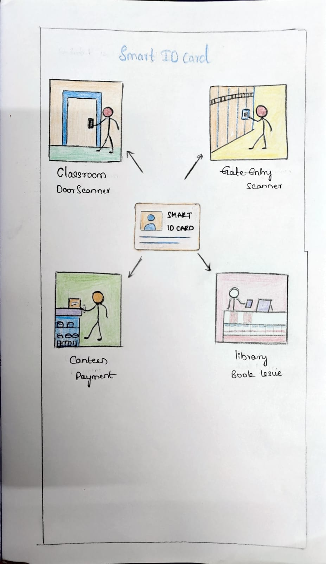

High-Fidelity Prototype
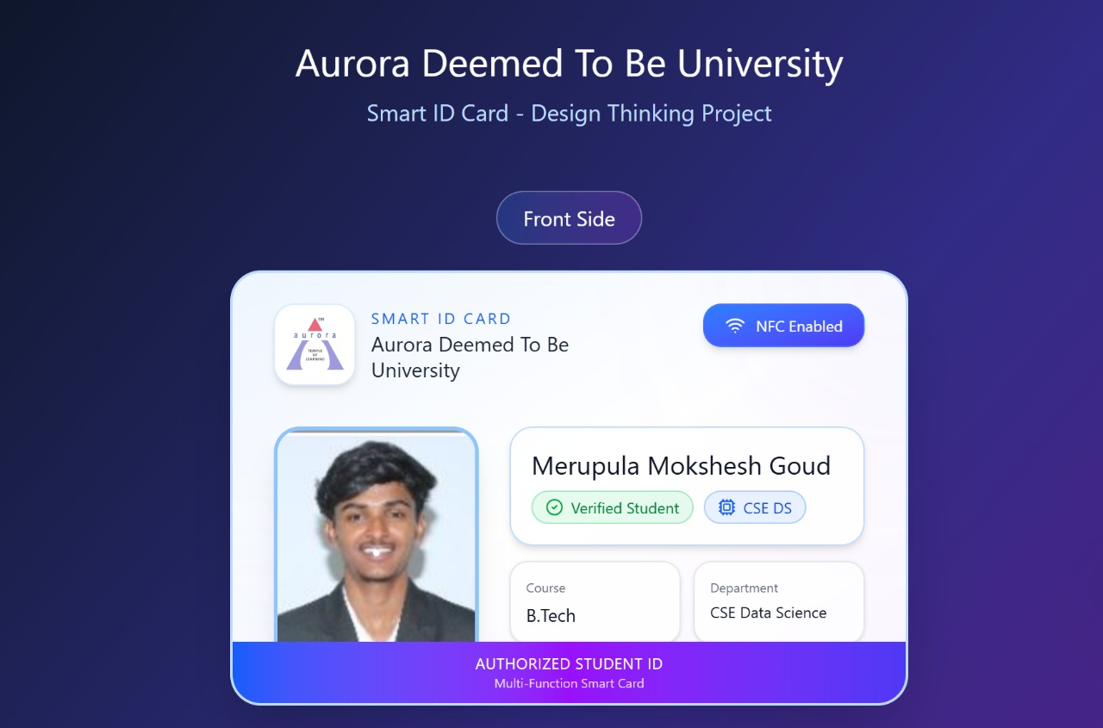
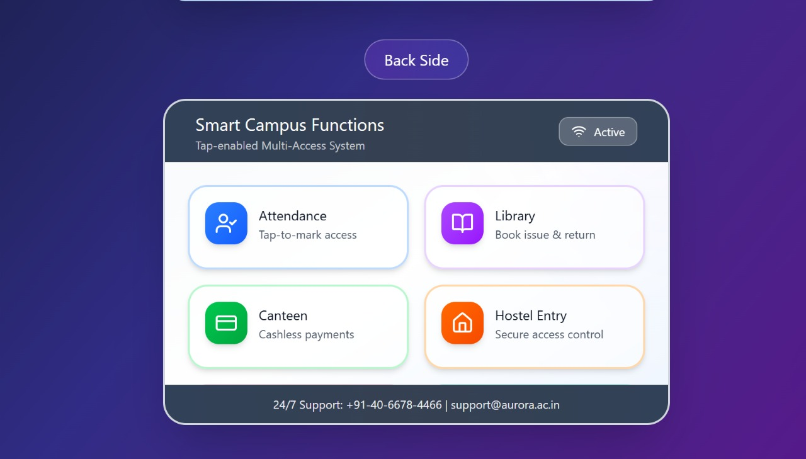
Step 3: Prototype Development Process
Low-Fidelity Prototype – Development Process
- First, I reviewed the problems identified in earlier labs such as slow attendance, gate delays, and manual checking.
- I decided the main campus functions to include: attendance, gate entry, canteen payment, and library book issue.
- I drew simple sketches showing a Smart ID card in the center and how it is used at different places like classroom door, gate, canteen, and library.
- I used arrows and labels to clearly show how one card connects to multiple campus functions.
- These sketches helped explain the idea quickly without using any software.
High-Fidelity Prototype – Development Process
- I planned the layout of the Smart ID card with student details such as name, course, department, and photo.
- I designed the front side of the card to show student identity, university name, NFC-enabled status, and verification.
- I designed the back side to display smart campus functions like attendance, library access, canteen payment, and hostel entry.
- I used colors, icons, and proper alignment to make the card look realistic and professional.
- This prototype helps users clearly understand how the final Smart ID Card will look and work in real campus situations.

